JOIN Practical: Vinoliah Makamu

Q.1.

List all orders along with the customer name and product name.
Expected Output Columns:
- OrderID, OrderDate, CustomerName, ProductName, Quantity

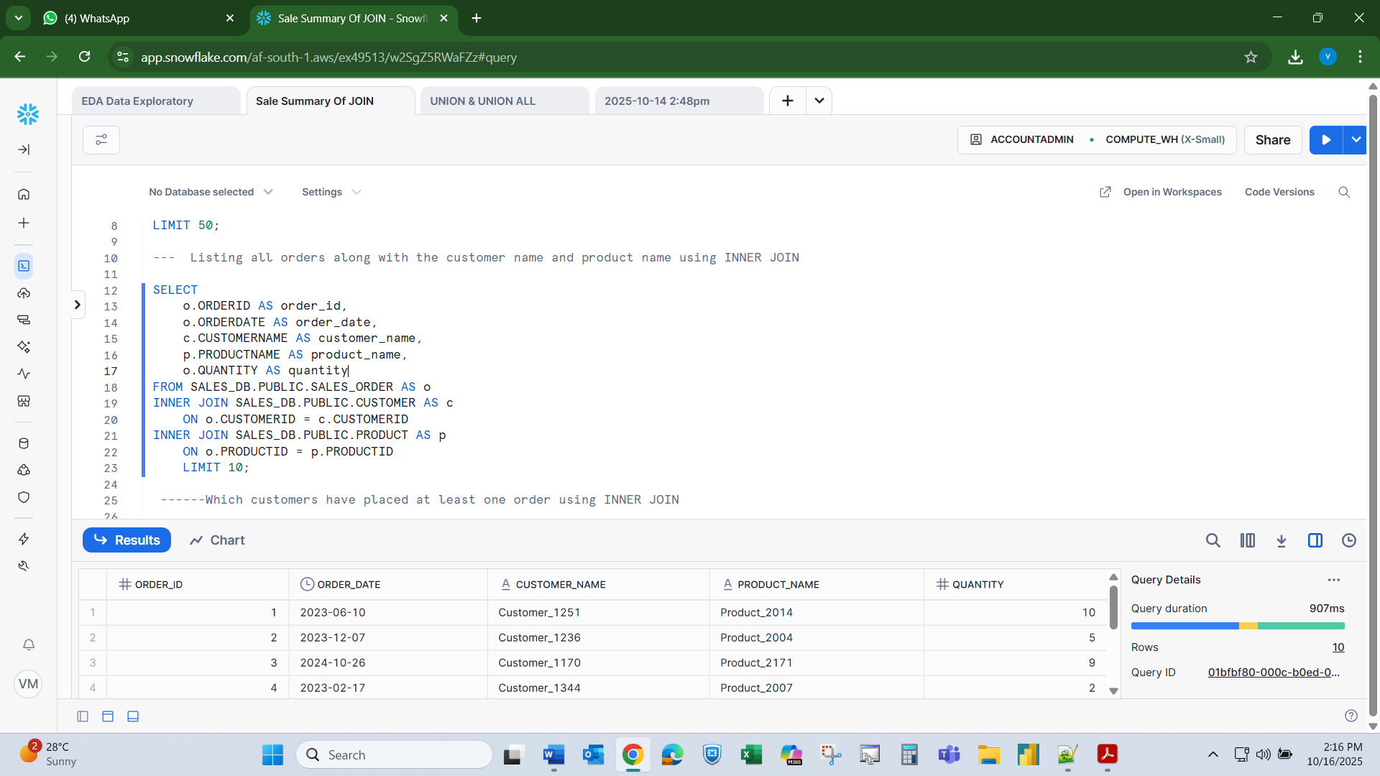

Q.2.

Which customers have placed at least one order?
Expected Output Columns:
- CustomerID, CustomerName, Country, OrderID, OrderDate

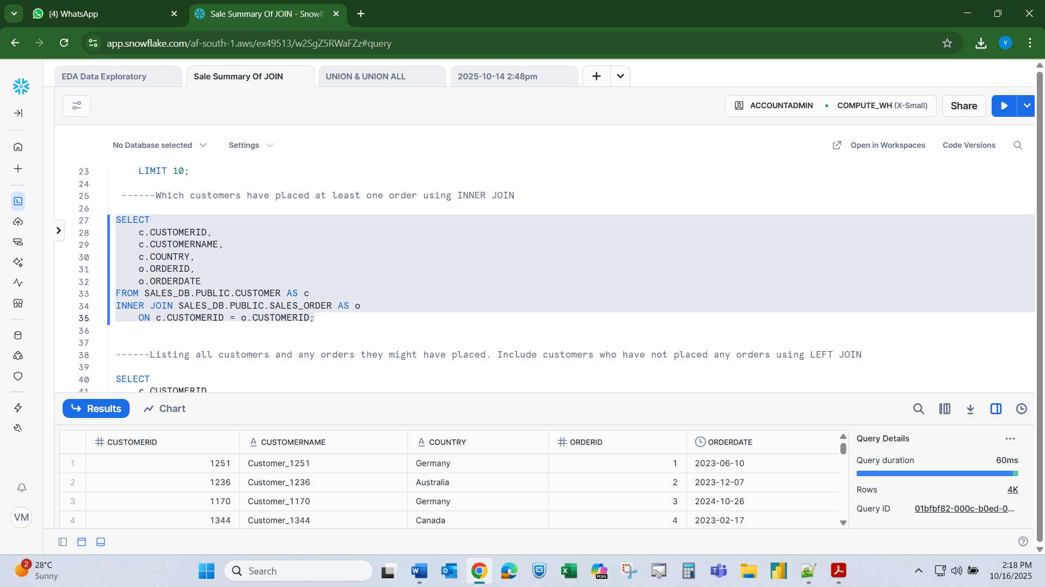

Q.3.

List all customers and any orders they might have placed. Include customers who have not placed any orders.
Expected Output Columns:
- CustomerID, CustomerName, Country, OrderID, OrderDate, ProductID, Quantity

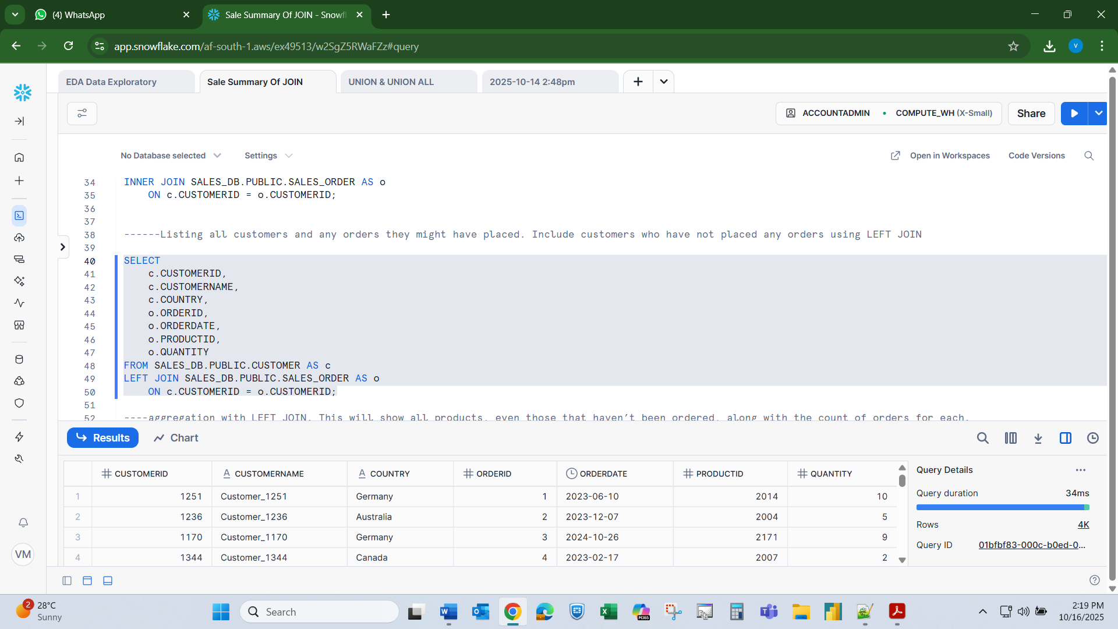

Q.4.

List all products and how many times each was ordered (if any).
Expected Output Columns:
- ProductID, ProductName, TotalOrders (TotalOrders is the count of how many times the product appears in orders)

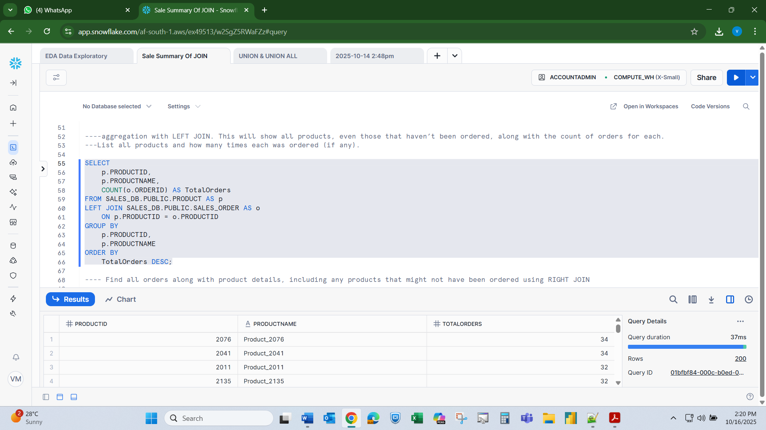

Q.5.

Find all orders along with product details, including any products that might not have been ordered.
Expected Output Columns:
- OrderID, OrderDate, ProductID, ProductName, Price, Quantity

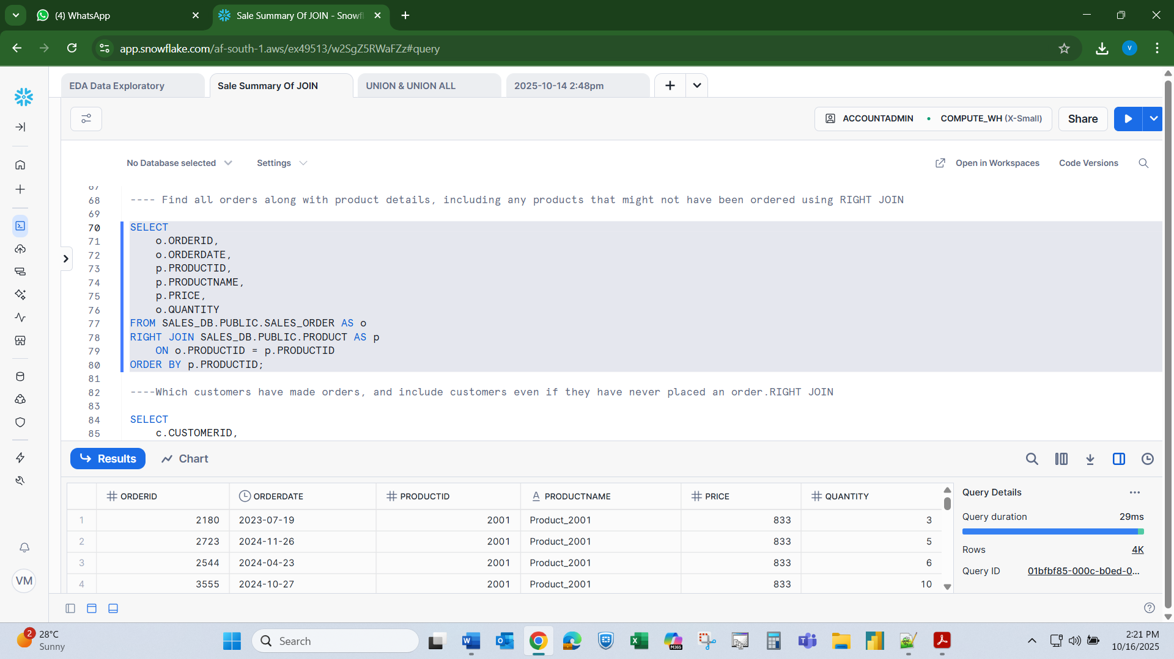

Q.6.

Which customers have made orders, and include customers even if they have never placed an order.
Expected Output Columns:
- CustomerID, CustomerName, Country, OrderID, OrderDate, ProductID, Quantity

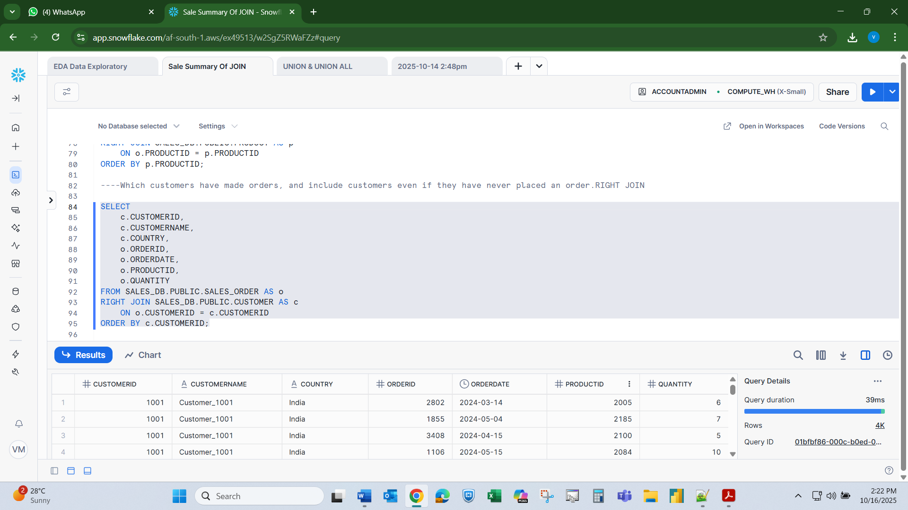

Q.7

List all customers and orders, showing NULLs where customers have not ordered or where orders have no customer info.
Expected Output Columns:
- CustomerID, CustomerName, Country, OrderID, OrderDate, ProductID, Quantity

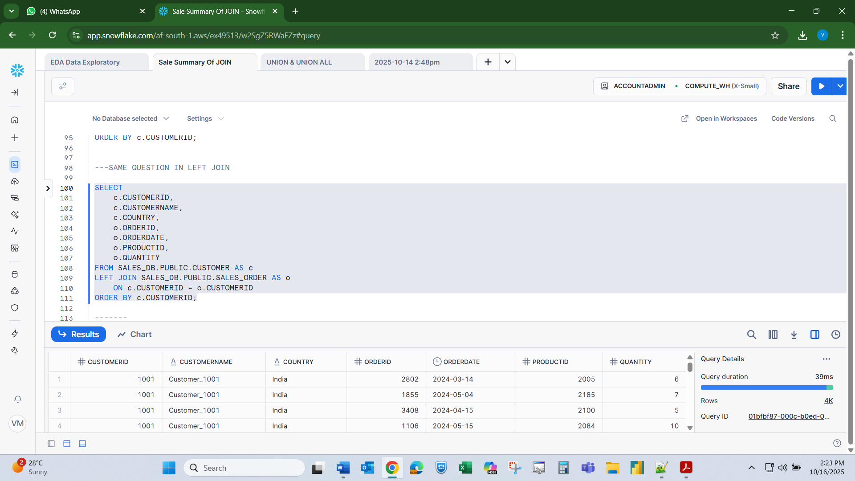

Q.8

List all products and orders, showing NULLs where products were never ordered or orders are missing product info.

Expected Output Columns:
- ProductID, ProductName, Price, OrderID, OrderDate, CustomerID, Quantity

